The Calligraphy Hub

**User Guide**

|  |  |  |
| --- | --- | --- |
| **SUPERVISOR** | **SIR TAHA ABBAS** | |
| **BATCH CODE** | **2501B2** | |
| **GROUP** | **A** | |
| **SERIAL NO** | **ENROLLMENT NUMBER** | **STUDENT NAME** |
| **1** | Student1634919 | ABDULLAH AHMED |
| **2** | Student1634905 | M HUSSAIN KHAN |
| **3** | Student1634911 | M RAZA KHAN |
| **4** | Student1611535 | M ARSALAN HASAN |

**NAVBAR:**

Using the navbar, the user can navigate through various categories. We have total 6 items in Navbar, which are further classified as:

* HOME
* ABOUT US
* CATAGERIES
* INFO
* CONTACT
* GALLERY



**HOME PAGE:**

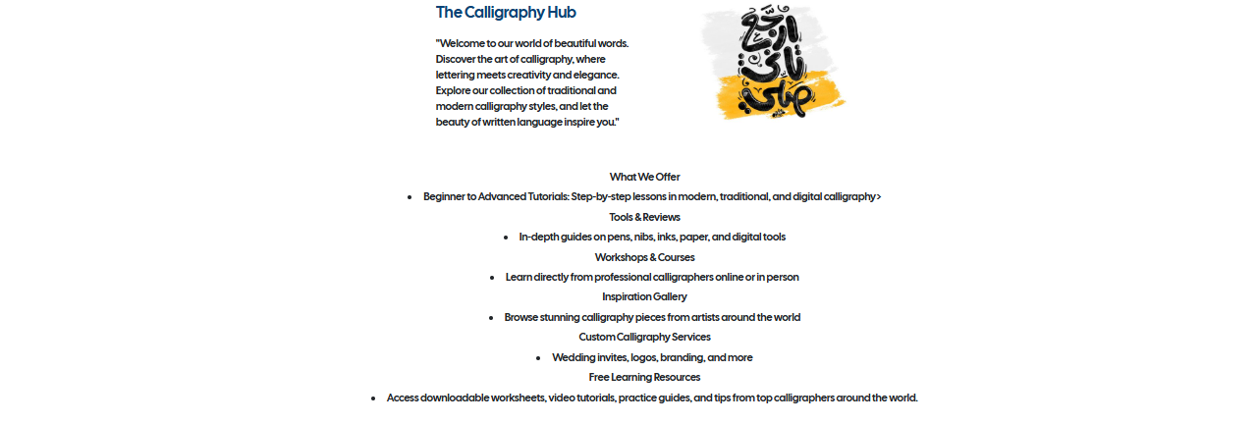

**ABOUT US PAGE:**

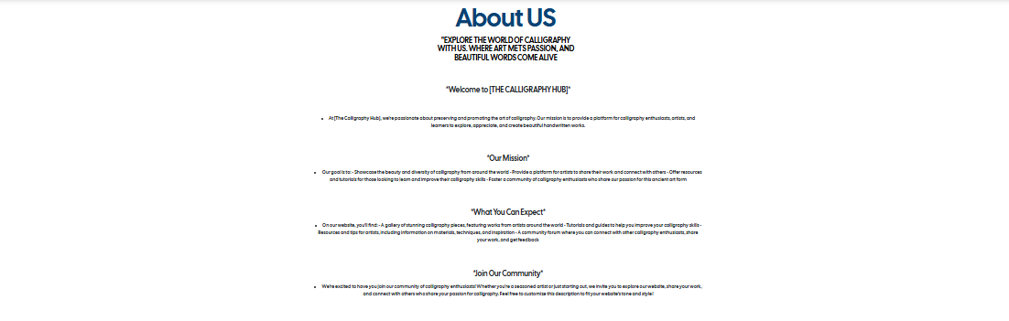

**CALLIGRAPHY INFO PAGE:**

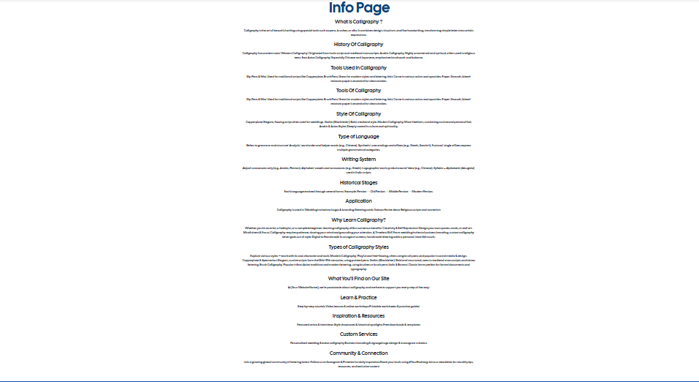

**GALLARY PAGE:**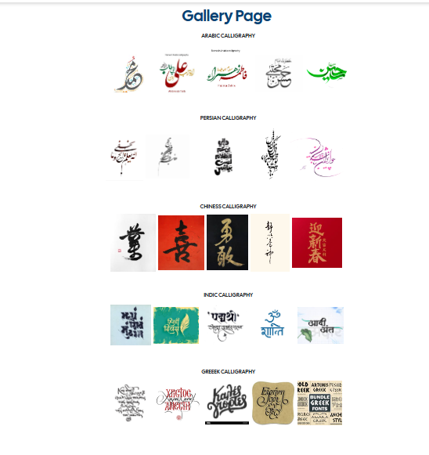

**FEED BACK PAGE:**

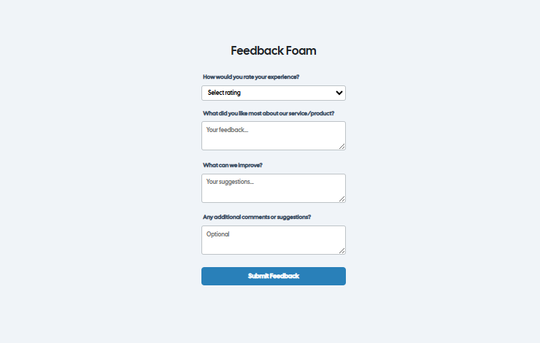

**CONTACT US PAGE:**

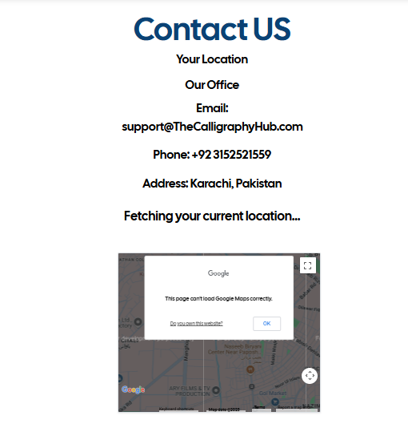

**GATAGERIES PAGE:**

